

# Department of Computer Science and Engineering Database Management Systems — CMPS 451 Dr. Rehab Duwairi | Fall 2023 Course Team Project

|  |  |  |
| --- | --- | --- |
| ***STUDENT NAME OF SECTION L51*** | ***STUDENT QUID*** | ***STUDENT EMAIL*** |
| Fatma Ali Elbakry Elbadrawy | 201901981 | fe1901981@qu.edu.qa |
| Ferial Mohamed Zakaria Awadalla Marzouk | 201706475 | fm1706475@qu.edu.qa |
| Sara Metwally Ramadan Said | 202004852 | ss2004852@qu.edu.qa |

**Part A — Chosen Entity-Relationship Diagram (ERD) and Tools**

Chosen Diagram: Airline ERD

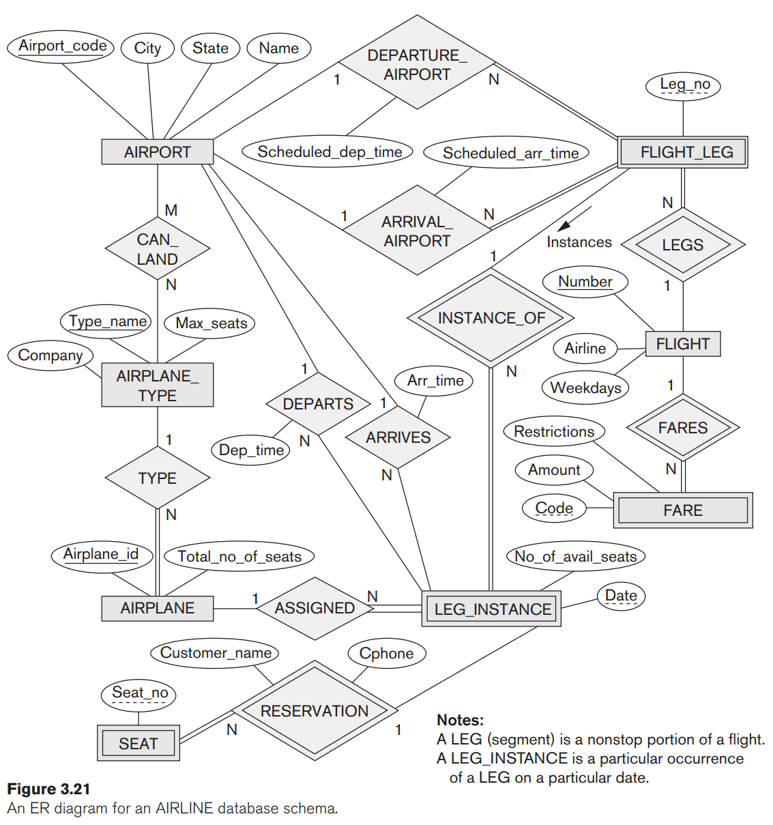  
Chosen Tools:

For the Relational Schema Creation, we chose to work with Microsoft Excel[1]. Oracle SQL Developer, our second tool, was used to create and populate the relations of the schema.

**Part B — Mapping the ER Schema to Relational Database Schema**

* First: We need to Identify all the “WEAK” and “STRONG” entities and the respective “Partial Key” and “Primary Key” of each one of the Entities.

|  |  |  |
| --- | --- | --- |
| **Entity** | **Primary/Partial Key** | **Entity Type** |
| AIRPORT | Airport_Code | STRONG |
| AIRPLANE | Airplane_ID | STRONG |
| AIRPLANE_TYPE | Type_Name | STRONG |
| FLIGHT | Number | STRONG |
| FLIGHT_LEG | Leg_NO | WEAK |
| LEG_INSTANCE | Date | WEAK |
| FARE | Code | WEAK |
| SEAT | Seat_NO | WEAK |

* Each STRONG entity will have its own relation (table), which will contain the primary key and the rest of the given attributes.
* Each WEAK entity, on the other hand, will have its own relation (table). However, since its partial key cannot stand on its own, the relation will contain a combined primary key which consists of the STRONG entity's primary key as a foreign key and the partial key. The given attributes will be added to the relation.
* Second: We need to map the relationship between entities and resolve them in the appropriate manner according to their connection and characteristics:

|  |  |  |
| --- | --- | --- |
| **Relationship** | **Cardinality** | **Attached Attributes** |
| CAN_LAND | M:N | — |
| DEPARTURE_AIRPORT | 1:N | Scheduled_dep_time |
| ARRIVAL_AIRPLANE | 1:N | Scheduled_arr_time |
| DEPARTS | 1:N | Dep_time |
| ARRIVES | 1:N | Arr_time |
| TYPE | 1:N | — |
| INSTANCE_OF | 1:N | — |
| LEGS | 1:N | — |
| FARES | 1:N | — |
| ASSIGNED | 1:N | — |
| RESERVATION | 1:N | Customer_Name Cphone |

* 1:N with no Relationship Attributes: These were resolved using the most common approach, which is adding the Foreign Key to either of the relations connected.
* 1:N with Relationship Attributes: These were resolved by adding the attributes to either of the relations alongside the Foreign Key if it is required for the connection between the two relations.
* M:N These were resolved using the most common approach, which is creating a new relation with the Primary Keys of both and adding them as a Foreign Key as well.

The following notes were kept in mind as assumptions to reach possible solutions in order to create the submitted schema for the selected database:

* + The tails of the arrows are where the foreign keys lie.
  + The tips of the arrows are where the foreign keys originate from.
  + The primary keys are made to be bolder than the rest of the attributes.
  + The surrogate keys were considered as an option to eliminate using combined primary keys, however, after some research, we have found that it cannot be used as “Search up” keys and is more expensive compared to the original solution. Additionally, we feared the impossibility of being able to not use them as “search up” keys could conflict with future requirements of the following phases of this project.
  + The SEAT entity and RESERVATION relationship were combined, for it did not seem logical to separate the seat information from the customer. It seemed unnecessary and added more relations for interlinked data.
  + The FLIGHT_LEG entity and DEPARTURE_AIRPORT and ARRIVAL_AIRPORT relationships were combined, for it seemed unnecessary and added more relations for data that are linked, since each flight leg departing, it must arrive.
  + The LEG_INSTANCE entity and DEPARTURE_TIME and ARRIVAL_TIME relationships were combined, for it seemed unnecessary and added more relations for data that are linked, since each leg instance departing, it must arrive.
  + The Airplane_ID was added to SEAT_RESERVATION and LEG_INSTANCE relations since it seemed necessary to connect such data together, for it would have not made sense without this addition.

The above rules of mapping of the STRONG and WEAK entities and the different relationships from the Entity-Relationship Diagram to a Relational Schema will give us the following different relations to make up our schema (Diagram is in the next page, it will also be attached as a PDF to the submission folder).

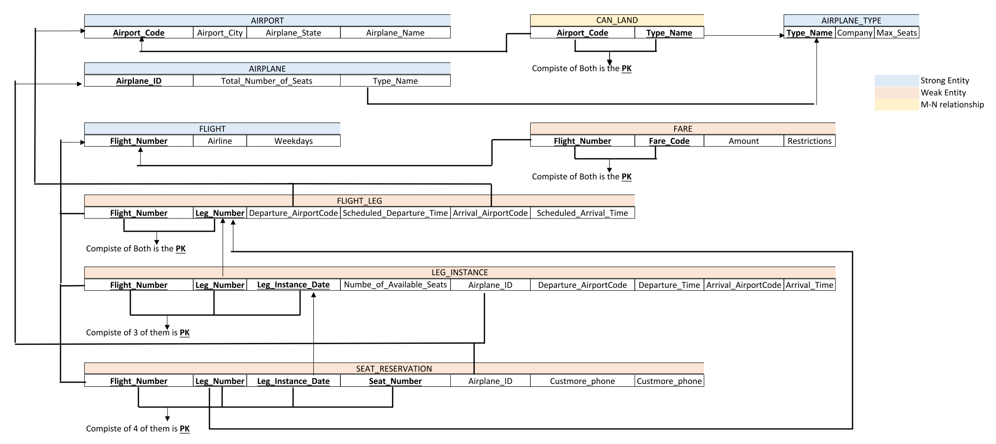

**Part C: SQL DDL statements to Create and Populate the Relations**

**C.1 — DDL Statements**

--DROPPING ALL TABLES IF NECESSARY

DROP TABLE AIRPORT;

DROP TABLE AIRPLANE;

DROP TABLE AIRPLANE_TYPE;

DROP TABLE CAN_LAND;

DROP TABLE FLIGHT;

DROP TABLE FLIGHT_LEG;

DROP TABLE FARE;

DROP TABLE LEG_INSTANCE;

DROP TABLE SEAT_RESERVATION;

--1. Create the AIRPORT relation

CREATE TABLE Airport(

Airport_Code CHAR(3) PRIMARY KEY,

Airport_City VARCHAR2(30) NOT NULL,

Airport_State VARCHAR2(30) NOT NULL,

Airport_Name VARCHAR2(50) NOT NULL

);

--2. Create the AIRPLANE_TYPE relation

CREATE TABLE AIRPLANE_TYPE(

Type_Name VARCHAR2(30) PRIMARY KEY,

Company VARCHAR2(30) NOT NULL,

Max_Seats INT NOT NULL,

CONSTRAINT CHECK__MAX_SEATS__AT CHECK (Max_Seats > 0 AND Max_Seats < 854),

CONSTRAINT CHECK__Type_Name__AT CHECK (Type_Name like 'Boeing 737'

OR Type_Name like 'Boeing 747'

OR Type_Name like 'Boeing 777'

OR Type_Name like 'Boeing 787 Dreamliner'

OR Type_Name like 'Airbus A320'

OR Type_Name like 'Airbus A380'

OR Type_Name like 'Embraer E175'

OR Type_Name like 'Embraer E190'

OR Type_Name like 'Bombardier CRJ900'

OR Type_Name like 'Cessna 172'

OR Type_Name like 'Gulfstream G650'

OR Type_Name like 'Bombardier CRJ700'

OR Type_Name like 'McDonnell Douglas MD-80'

OR Type_Name like 'Beechcraft King Air'

OR Type_Name like 'Lockheed C-130 Hercules')

);

--3. Create the CAN_LAND relation for the many-to-many relationship

CREATE TABLE CAN_LAND(

Airport_Code CHAR(3),

Type_Name VARCHAR2(30),

PRIMARY KEY (Airport_Code, type_name),

FOREIGN KEY (Airport_Code) REFERENCES AIRPORT(Airport_Code),

FOREIGN KEY (Type_Name) REFERENCES AIRPLANE_TYPE(Type_Name)

);

--4. Create the FLIGHT relation

CREATE TABLE FLIGHT(

Flight_Number VARCHAR2(6) NOT NULL,

Airline VARCHAR2(20) NOT NULL,

Weekdays VARCHAR2(21) NOT NULL,

PRIMARY KEY (Flight_Number)

);

--5. Create the FARE relation

CREATE TABLE FARE(

Flight_Number VARCHAR2(6) NOT NULL,

Fare_Code VARCHAR2(10) NOT NULL,

Amount NUMBER(8, 2) NOT NULL,

Restrictions VARCHAR(50),

PRIMARY KEY (Flight_Number, Fare_Code),

CONSTRAINT FK__FLIGHT_NUMBER__F FOREIGN KEY (Flight_Number) REFERENCES FLIGHT(Flight_Number)

);

--6. Create the AIRPLANE relation

CREATE TABLE AIRPLANE(

Airplane_ID VARCHAR2(7) NOT NULL,

Total_Number_of_Seats NUMBER(3) NOT NULL,

Type_Name VARCHAR2(23) NOT NULL,

CONSTRAINT PK__AIRPLANE__A PRIMARY KEY (Airplane_ID),

CONSTRAINT FK__Type_Name__A FOREIGN KEY (Type_Name) REFERENCES AIRPLANE_TYPE(Type_Name),

CONSTRAINT CHK__TOTAL_NO_OF_SEATS__A CHECK (Total_Number_of_SEATS > 0 AND Total_Number_of_SEATS < 854)

);

--7. Create the FLIGHT_LEG relation

CREATE TABLE FLIGHT_LEG (

Flight_Number VARCHAR2(6) NOT NULL,

Leg_Number NUMBER(1) NOT NULL,

Departure_AirportCode CHAR(3) NOT NULL,

Scheduled_Departure_Time VARCHAR2(4) NOT NULL,

Arrival_AirportCode CHAR(3) NOT NULL,

Scheduled_Arival_Time VARCHAR2(4) NOT NULL,

PRIMARY KEY (Flight_Number, Leg_Number),

CONSTRAINT FK__FLIGHT_NUMBER__FL FOREIGN KEY (Flight_Number) REFERENCES FLIGHT(Flight_Number),

CONSTRAINT FK__AIRPORT_CODE__FL FOREIGN KEY (Departure_AirportCode) REFERENCES Airport(Airport_Code),

CONSTRAINT FK__AIRPORT2_CODE__FL FOREIGN KEY (Arrival_AirportCode) REFERENCES Airport(Airport_Code)

);

--8. Create the LEG INSTANCE relation

CREATE TABLE LEG_INSTANCE(

Flight_Number VARCHAR2(6) NOT NULL,

Leg_Number NUMBER(1) NOT NULL,

Leg_Instance_Date DATE NOT NULL,

Airplane_ID VARCHAR2(8) NOT NULL,

Number_of_Avialable_Seats NUMBER(3) NOT NULL,

Departure_AirportCode VARCHAR2(3) NOT NULL,

Departure_Time VARCHAR2(4) NOT NULL,

Arrival_AirportCode VARCHAR2(3) NOT NULL,

Arrival_Time VARCHAR2(4) NOT NULL,

CONSTRAINT PK__LEG_INSTANCE__LI PRIMARY KEY (Flight_Number, Leg_Number, Leg_Instance_Date),

CONSTRAINT FK__FLIGHT_LEG_NUMBER__LI FOREIGN KEY (Flight_Number, Leg_Number) REFERENCES FLIGHT_LEG(Flight_Number, Leg_Number),

CONSTRAINT FK__AIRPLANE_ID__LI FOREIGN KEY (Airplane_ID) REFERENCES Airplane(Airplane_ID),

CONSTRAINT CHK__NO_OF_AVAILABLE_SEATS__LI CHECK (Number_of_Avialable_Seats > 0 AND Number_of_Avialable_Seats < 854)

);

--9. Create the SEAT RESERVATION relation

CREATE TABLE SEAT_RESERVATION(

Flight_Number VARCHAR2(6) NOT NULL,

Leg_Number NUMBER(1) NOT NULL,

Leg_Instance_Date DATE NOT NULL,

Seat_Number VARCHAR(4) NOT NULL,

Customer_Name VARCHAR2(35) NOT NULL,

Customer_Phone VARCHAR2(15) NOT NULL,

AIRPLANE_ID VARCHAR2(10) NOT NULL,

CONSTRAINT PK__SEAT_RESERVATION__SR PRIMARY KEY (Flight_Number, Leg_Number, Leg_Instance_Date, Seat_Number),

CONSTRAINT FK__SEAT_RESERVATION__SR FOREIGN KEY (Flight_Number, Leg_Number, Leg_Instance_Date) REFERENCES LEG_INSTANCE(Flight_Number, Leg_Number, Leg_Instance_Date),

CONSTRAINT FK__AIRPLANE_ID__SR FOREIGN KEY (Airplane_ID) REFERENCES Airplane(Airplane_ID)

);

**C.2 — Populating Table**

--1. Populating the AIRPORT relation

INSERT INTO AIRPORT(Airport_Code, Airport_City, Airport_State, Airport_Name)

VALUES ('JFK', 'New York', 'NY', 'John F. Kennedy International Airport');

INSERT INTO AIRPORT(Airport_Code, Airport_City, Airport_State, Airport_Name)

VALUES ('LAX', 'Los Angeles', 'CA', 'Los Angeles International Airport');

INSERT INTO AIRPORT(Airport_Code, Airport_City, Airport_State, Airport_Name)

VALUES ('ORD', 'Chicago', 'IL', 'Los Angeles International Airport');

INSERT INTO AIRPORT(Airport_Code, Airport_City, Airport_State, Airport_Name)

VALUES ('DFW', 'Dallas', 'TX', 'Dallas/Fort Worth International Airport');

INSERT INTO AIRPORT(Airport_Code, Airport_City, Airport_State, Airport_Name)

VALUES ('ATL', 'Atlanta', 'GA', 'Hartsfield-Jackson Atlanta International Airport');

INSERT INTO AIRPORT(Airport_Code, Airport_City, Airport_State, Airport_Name)

VALUES('DOH', 'DOHA', 'DOHA', 'HAMAD INTERNATIONAL AIRPORT');

--2. Populating the AIRPLANE_TYPE relation

INSERT INTO AIRPLANE_TYPE(Type_Name, Company, Max_Seats)

VALUES ('Boeing 737', 'Boeing', 215);

INSERT INTO AIRPLANE_TYPE(Type_Name, Company, Max_Seats)

VALUES ('Airbus A320', 'Airbus', 220);

INSERT INTO AIRPLANE_TYPE(Type_Name, Company, Max_Seats)

VALUES ('Embraer E175', 'Embraer', 88);

INSERT INTO AIRPLANE_TYPE(Type_Name, Company, Max_Seats)

VALUES ('Bombardier CRJ900', 'Bombardier', 76);

INSERT INTO AIRPLANE_TYPE(Type_Name, Company, Max_Seats)

VALUES ('Bombardier CRJ700', 'Boeing', 550);

--3. Populating the CAN_LAND relation

INSERT INTO CAN_LAND(Airport_Code, Type_Name)

VALUES ('JFK', 'Boeing 737');

INSERT INTO CAN_LAND(Airport_Code, Type_Name)

VALUES ('LAX', 'Airbus A320');

INSERT INTO CAN_LAND(Airport_Code, Type_Name)

VALUES ('ORD', 'Embraer E175');

INSERT INTO CAN_LAND(Airport_Code, Type_Name)

VALUES ('DFW', 'Bombardier CRJ900');

INSERT INTO CAN_LAND(Airport_Code, Type_Name)

VALUES ('ATL', 'Bombardier CRJ700');

--4. Populating the FLIGHT relation

INSERT INTO FLIGHT (Flight_Number, Airline, Weekdays )

VALUES('QA1306', 'QATAR AIRWAYS', 'SUN FRI' );

INSERT INTO FLIGHT (Flight_Number, Airline, Weekdays )

VALUES('QA1505', 'QATAR AIRWAYS', 'TUE THU' );

INSERT INTO FLIGHT (Flight_Number, Airline, Weekdays )

VALUES('DL1207', 'Delta Air Lines', 'SAT MON' );

INSERT INTO FLIGHT (Flight_Number, Airline, Weekdays )

VALUES('AA1109', 'American Airlines', 'SUN WED' );

INSERT INTO FLIGHT (Flight_Number, Airline, Weekdays )

VALUES('AS1104', 'Alaska Airlines', 'WED SAT' );

INSERT INTO FLIGHT (Flight_Number, Airline, Weekdays )

VALUES('LAA1302', 'LOS ANGLES AIRWAYS', 'THR SAT' );

--5. Populating the FLIGHT_LEG relation

INSERT INTO FLIGHT_LEG (Flight_Number, Leg_Number,

Departure_AirportCode, Scheduled_Departure_Time,Arrival_AirportCode,

Scheduled_Arival_Time)

VALUES('QA1306', 1,'DOH', '1100', 'ORD','1320' );

INSERT INTO FLIGHT_LEG (Flight_Number, Leg_Number,

Departure_AirportCode, Scheduled_Departure_Time,Arrival_AirportCode,

Scheduled_Arival_Time)

VALUES('QA1505', 1,'DOH', '1205', 'JFK','1425' );

INSERT INTO FLIGHT_LEG (Flight_Number, Leg_Number,

Departure_AirportCode, Scheduled_Departure_Time,Arrival_AirportCode,

Scheduled_Arival_Time)

VALUES('LAA1302', 1,'LAX', '1030', 'DFW','1450' );

INSERT INTO FLIGHT_LEG (Flight_Number, Leg_Number,

Departure_AirportCode, Scheduled_Departure_Time,Arrival_AirportCode,

Scheduled_Arival_Time)

VALUES('AA1109', 1,'JFK', '1515', 'ATL','1720' );

INSERT INTO FLIGHT_LEG (Flight_Number, Leg_Number,

Departure_AirportCode, Scheduled_Departure_Time,Arrival_AirportCode,

Scheduled_Arival_Time)

VALUES('DL1207', 1,'DFW', '1905', 'ATL','2215' );

--6. Populating the Fare table

INSERT INTO FARE(Flight_Number, Fare_Code, Amount, Restrictions )

VALUES('QA1306', '10001', 5000, 'NO REFUND IF CANCELLED');

INSERT INTO FARE(Flight_Number, Fare_Code, Amount, Restrictions )

VALUES('QA1505', '10002', 6000, 'NO REFUND IF CANCELLED');

INSERT INTO FARE(Flight_Number, Fare_Code, Amount, Restrictions )

VALUES('LAA1302', '10003', 7000, 'NO REFUND IF CANCELLED');

INSERT INTO FARE(Flight_Number, Fare_Code, Amount, Restrictions )

VALUES('AA1109', '10004', 8000, 'NO REFUND IF CANCELLED');

INSERT INTO FARE(Flight_Number, Fare_Code, Amount, Restrictions )

VALUES('DL1207', '10005', 9000, 'NO REFUND IF CANCELLED');

--7. Populating the AIRPLANE relation

INSERT INTO AIRPLANE(Airplane_ID, Total_Number_of_Seats, Type_Name)

VALUES ('JFK-101', 215, 'Boeing 737');

INSERT INTO AIRPLANE(Airplane_ID, Total_Number_of_Seats, Type_Name)

VALUES ('JFK-102', 215, 'Boeing 737');

INSERT INTO AIRPLANE(Airplane_ID, Total_Number_of_Seats, Type_Name)

VALUES ('LAX-101', 220, 'Airbus A320');

INSERT INTO AIRPLANE(Airplane_ID, Total_Number_of_Seats, Type_Name)

VALUES ('ORD-101', 88, 'Embraer E175');

INSERT INTO AIRPLANE(Airplane_ID, Total_Number_of_Seats, Type_Name)

VALUES ('DFW-101', 76, 'Bombardier CRJ900');

INSERT INTO AIRPLANE(Airplane_ID, Total_Number_of_Seats, Type_Name)

VALUES ('ATL-101', 550, 'Bombardier CRJ700');

--8. Populating the LEG INSTANCE relation

INSERT INTO LEG_INSTANCE(Flight_Number, Leg_Number, Leg_Instance_Date, Airplane_ID,

Number_of_Avialable_Seats, Departure_AirportCode,

Arrival_AirportCode, Departure_Time, Arrival_Time)

VALUES('DL1207', 1, '10-JAN-2023', 'JFK-101', 25, 'DFW', 'ATL', '1910','2230');

INSERT INTO LEG_INSTANCE(Flight_Number, Leg_Number, Leg_Instance_Date, Airplane_ID,

Number_of_Avialable_Seats, Departure_AirportCode,

Arrival_AirportCode, Departure_Time, Arrival_Time)

VALUES('QA1505', 1, '10-JAN-2023', 'JFK-101', 26, 'DOH', 'JFK', '1210', '1445');

INSERT INTO LEG_INSTANCE(Flight_Number, Leg_Number, Leg_Instance_Date, Airplane_ID,

Number_of_Avialable_Seats, Departure_AirportCode,

Arrival_AirportCode, Departure_Time, Arrival_Time)

VALUES('AA1109', 1, '10-JAN-2023', 'JFK-101', 26, 'JFK', 'ATL', '1515', '1720');

INSERT INTO LEG_INSTANCE(Flight_Number, Leg_Number, Leg_Instance_Date, Airplane_ID,

Number_of_Avialable_Seats, Departure_AirportCode,

Arrival_AirportCode, Departure_Time, Arrival_Time)

VALUES('QA1306', 1, '10-JAN-2023', 'JFK-101', 26, 'DOH', 'ORD', '1100', '1320');

INSERT INTO LEG_INSTANCE(Flight_Number, Leg_Number, Leg_Instance_Date, Airplane_ID,

Number_of_Avialable_Seats, Departure_AirportCode,

Arrival_AirportCode, Departure_Time, Arrival_Time)

VALUES('LAA1302', 1, '10-JAN-2023', 'JFK-101', 26, 'LAX', 'DFW', '1100', '1320');

--9. Populating the SEAT RESERVATION relation

INSERT INTO SEAT_RESERVATION(Flight_Number, Leg_Number, Leg_Instance_Date,

Seat_Number, Customer_Name, Customer_Phone, AIRPLANE_ID)

VALUES('LAA1302', 1,'10-JAN-2023', 'J26', 'NORA JANE','66288188','JFK-101');

INSERT INTO SEAT_RESERVATION(Flight_Number, Leg_Number, Leg_Instance_Date,

Seat_Number, Customer_Name, Customer_Phone, AIRPLANE_ID)

VALUES('LAA1302', 1,'10-JAN-2023', 'A25', 'FATMA ALAA','66218188','JFK-101');

INSERT INTO SEAT_RESERVATION(Flight_Number, Leg_Number, Leg_Instance_Date,

Seat_Number, Customer_Name, Customer_Phone, AIRPLANE_ID)

VALUES('LAA1302', 1,'10-JAN-2023', 'B25', 'SARA BAHER','66218128','JFK-101');

INSERT INTO SEAT_RESERVATION(Flight_Number, Leg_Number, Leg_Instance_Date,

Seat_Number, Customer_Name, Customer_Phone, AIRPLANE_ID)

VALUES('LAA1302', 1,'10-JAN-2023', 'C25', 'FARAH BAHEER','65218128','JFK-101');

INSERT INTO SEAT_RESERVATION(Flight_Number, Leg_Number, Leg_Instance_Date,

Seat_Number, Customer_Name, Customer_Phone, AIRPLANE_ID)

VALUES('LAA1302', 1,'10-JAN-2023', 'D25', 'MARAH BAHOR','66248128','JFK-101');

**Part D: Screenshots of the Populating**

The screenshots are provided with the submission.

1. A Legend is going to be provided explaing the usage and meaning of each sybmol used by our Relational Schema designing tool.